
About Us
Digital Pracharak
Founded by Shubham Sohani and Ravi Panwar, a dedicated marketing and advertising agency, Digital Pracharak, to provide all businesses with the possibility to interact with the digital world.We've been trained to turn your ideas into reality and produce high-quality results.
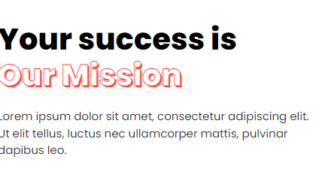

Our Mission
You describe your vision to us. We can help you make it a reality by providing top-notch digital marketing solutions tailored to your specific needs. Our diverse services cover it all with zeal and dedication, from digital marketing to web design and content development to SEO and social media marketing.
We provide world-class service with a team of over 13 people. We are excited to extend our business and assist any organisation seeking assistance in this field.
- World Class Service
- A dedicated team of professionals
- On-time delivery
- Our clients are our topmost priority
- All we look forward to is your success

We know what we're doing and have much experience. Every member of our team is a specialist in the product they support. Our team has completed several tedious and challenging projects and with such a level of experience we are here to help you.
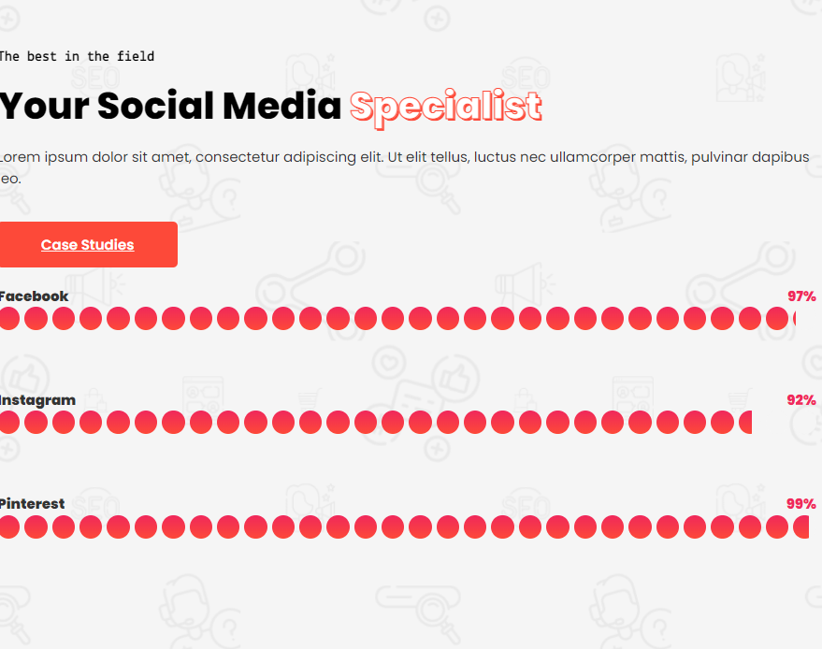
Social media has become an integral part of every business, thus if you want to expand your business through social media, well, you can rely on us blindly.


